Saratoga Mountain National Park

The Department of the Interior has named the Saratoga Mountain area a national park. It is in the planning stages of developing a campsite area over 500 acres of currently undeveloped land. This campsite will span the extremities of the park, from the proposed Mission Creek Campsite area in the west to the Wild Coyote Campsite area in the east.

At this time, all the contracts for this project have been awarded, with the exception of selecting the company that will develop the management information system (MIS) for Saratoga National Park. The three bidders for this contract are: (1) QM Associates, (2) MS Infostructures, and (3) the SBAE Company.

The project has been subdivided into 10 individual activities, as depicted in the PERT/CPM network shown below. Activity J is the MIS task.

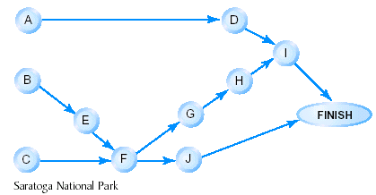

Based on similar projects, it has been possible to determine a cost/time correspondence between the various activities of the project. The normal and crash costs and times (in weeks) are given in the following table.

Activity | Normal Time | Normal Cost | Crash Time | Crash Cost
A | 15 | $ 85,000 | C | $165,000
B | 12 | $ 4D,000 | 6 | $10D,000
C | 2A | $ 90,000 | 1A | $250,000
D | 2B | $145,000 | 16 | $315,000
E | 10 | $1B0,000 | 4 | $220,000
F (Ellis Electric)
G | 1C | $200,000 | 2 | $600,000
H | 12 | $1D5,000 | 6 | $4D5,000
I (Harriman Construction)
J MIS PROJECT

Activity F, which will be performed by Ellis Electric, involves laying the electrical cable for the project. To minimize its cost, Ellis Electric will design the system to use the least amount of electrical cable.

Ellis Electric will charge the government an amount between $1A0,000 and $2A0,000. For $1A0,000, Ellis Electric can assign enough workers to lay 3B0 feet of cable per week. For $2A0,000, Ellis will assign additional workers to lay 5B0 feet of cable each week.

Activity I involves constructing one (narrow) paved two-lane road from Mission Creek in the west to Wild Coyote in the east. This work will be done by Harriman Construction. To minimize the costs, the department will pay Harriman to build the road of minimum distance between the two campsites. At a cost to the government of $2C,000 per week, 2D0 feet of roadway can be completed in a week. If the cost is increased to $3C,000 per week, the completion rate will increase to 30D feet per week.

Due to the heavy brush and mountainous nature of the area, 13 possible dirt paths exist between the campsites. Neither Ellis Electric nor Harriman Construction is permitted to clear out additional areas for constructing either underground cable or the paved road. Thus, the electrical cable must be laid and the road must be built along areas of the dirt paths. A map of the proposed project (not drawn to scale) showing the distances in feet of these paths between the campsites is given below.

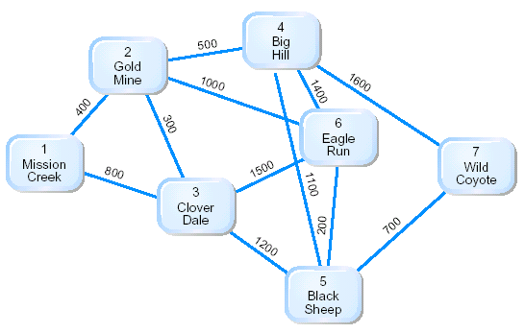

Each of three companies competing for the MIS task has been asked to submit a minimal cost and a minimal time (in weeks) bid. The bids are summarized in the following table.

 | Minimum Cost Bid |  | Minimum Time Bid
Company | Bid | Time | Time | Bid
QM | $150,000 | 4A | 2A | $350,000
MS | $250,000 | 3B | 1C | $450,000
SBAE | $300,000 | 2D | 8 | $600,000

The ‘‘grand opening’’ of Saratoga National Park has been scheduled for exactly 56 weeks from now. It is imperative that the project be completed within the 56-week period because a delay of even one day in the opening of the park would result in revised travel costs for the dignitaries, lost income to the park, and other expenses.

Based on the given time and cost estimates, prepare a report giving the costs and scheduling for each activity so that the project will be completed within 56 weeks at minimum total cost to the Department of the Interior. Be sure to emphasize the assumptions you made to perform your analysis. Include in your report:

- A recommendation for which firm should be awarded the MIS contract and its funding level
- A recommendation for the layout and funding for the Ellis Electric cable-laying activity
- A recommendation for the design and funding for the Harriman Construction paved road activity.

